****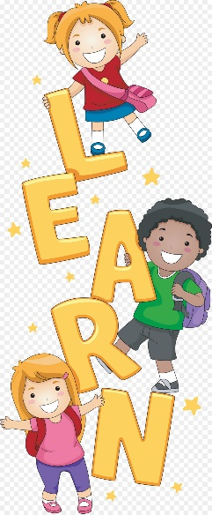

**Reminders**

* **October 2019 Half Term** will be up and running from **Monday 21st to Friday 25th October2019.** You must advise by the **7th October** if your child will be attending. If we don’t have enough numbers by this date we will **not** be opening. Thank you in advance for your cooperation.
* If your child will be attending any **after school clubs at their school** please inform us ASAP.
* Please ensure **payments** are made **ON TIME.** You **must use your child’s name as a reference**. Failure to do so will **incur extra charges** due to finance administrators having to do extra searches for who payment belongs to.
* **You must inform us if your child is absent from school**. You will be **charged** extra if you fail to inform us.
* If someone else will be collecting your child from the club, please **inform staff before they arrive**. They must know the password.
* Please note mobile phones are **not** permitted within our facility. No phone calls are allowed inside our building.

**This Month’s Learning**

* Black History Month
* Diwali

**HAPPY BIRTHDAY!**

Little Strawberries staff and children would like to wish ***Iyziah and Ramell*** a very Happy Birthday. Their birthday’s fall in the months of October and we wish them a very exciting upcoming year!

Hello Parents and Carers,

Please see all relevant information for October 2019. Thank you for all your good communication throughout September.

**YOUR FEEDBACK IS NEEDED!**

Little Strawberries would appreciate if parents could take time out and fill out a review on your experience at the Club! You do not need a hoop account. Simply follow the link below:

[**https://hoop.co.uk/little-strawberries/review/**](https://hoop.co.uk/little-strawberries/review/)

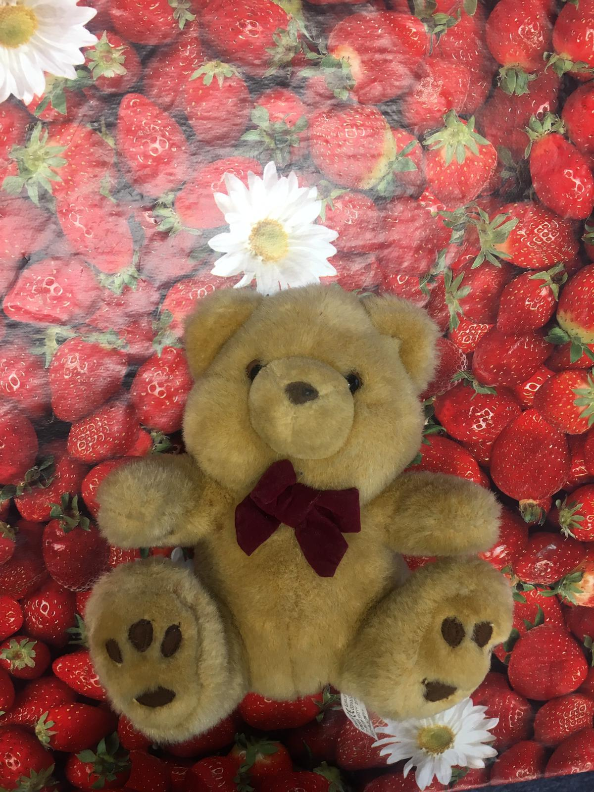

**Barnaby Bear Diary**

As part of our on-going parent/child relationship with Little Strawberries we are excited to introducing ‘Travels Barnaby Bear’.

What this entails is your child/children will be chosen to take Barnaby home for 3 days; in this time we would like you to capture your child with Barnaby Bear, whatsapp or email us some pictures of what your child is doing with Barnaby Bear. This can either be reading, going football, going swimming, making a cake, creating a den for him, visiting grandma etc. Any adventures or activities your child may be excited to share with us with Barnaby Bear will be put into a book for all the children to share and talk about.

We would be grateful if when you have Barnaby Bear, that you look after him, keep him clean and please remember to bring him back on time so that each child can get a chance to have Barnaby Bear.

Thank you in advance.